Introduction to PHP

What is PHP?
PHP was originally an acronym for Personal Home Pages, but is now a recursive acronym for “PHP: Hypertext Preprocessor”
PHP is a widely-used, open source scripting language
PHP scripts are executed on the server
PHP is free to download and use

What is a PHP File?
- PHP files can contain text, HTML, CSS, JavaScript, and PHP code
- PHP code are executed on the server, and the result is returned to the browser as plain HTML
- PHP files must have the extension ".php"

What Can PHP Do?
- PHP can generate dynamic page content
- PHP can create, open, read, write, delete, and close files on the server
- PHP can collect form data
- PHP can send and receive cookies
- PHP can add, delete, modify data in your database
- PHP can be used to control user-access
- PHP can encrypt data
With PHP you are not limited to output HTML. You can output images, PDF files, and even Flash movies. You can also output any text, such as XHTML and XML.

How does PHP work?
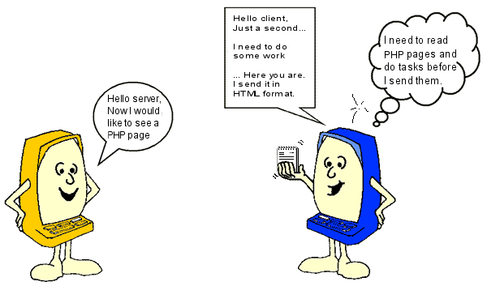
The server first reads the PHP file carefully to see if there are any tasks that need to be executed. Only when the server has done what it is supposed to do is the result sent back to the browser. It is important to understand that the user only sees the result of the server's work, not the PHP.
Page requested
Page returned in HTML format
Web Browser
SQL Database
Mail Server
File System
Web Server
PHP File
PHP Interpreter
File

This means that if you click "view source" on a PHP page, you do not see the PHP codes - only the HTML that the server has put together. Therefore, you cannot see how a PHP page is made by using "view source".

